Guidance for Topic 7 DQ 1
- Go to https://finance.yahoo.com/ In “Search,” enter the name of the company that you need to look up the price of their stock.

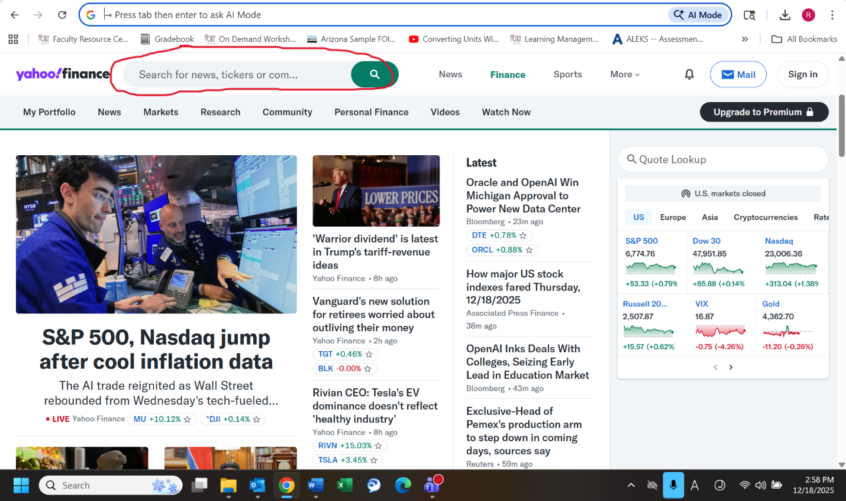

- Click "Historical Data" on the left side of the page.
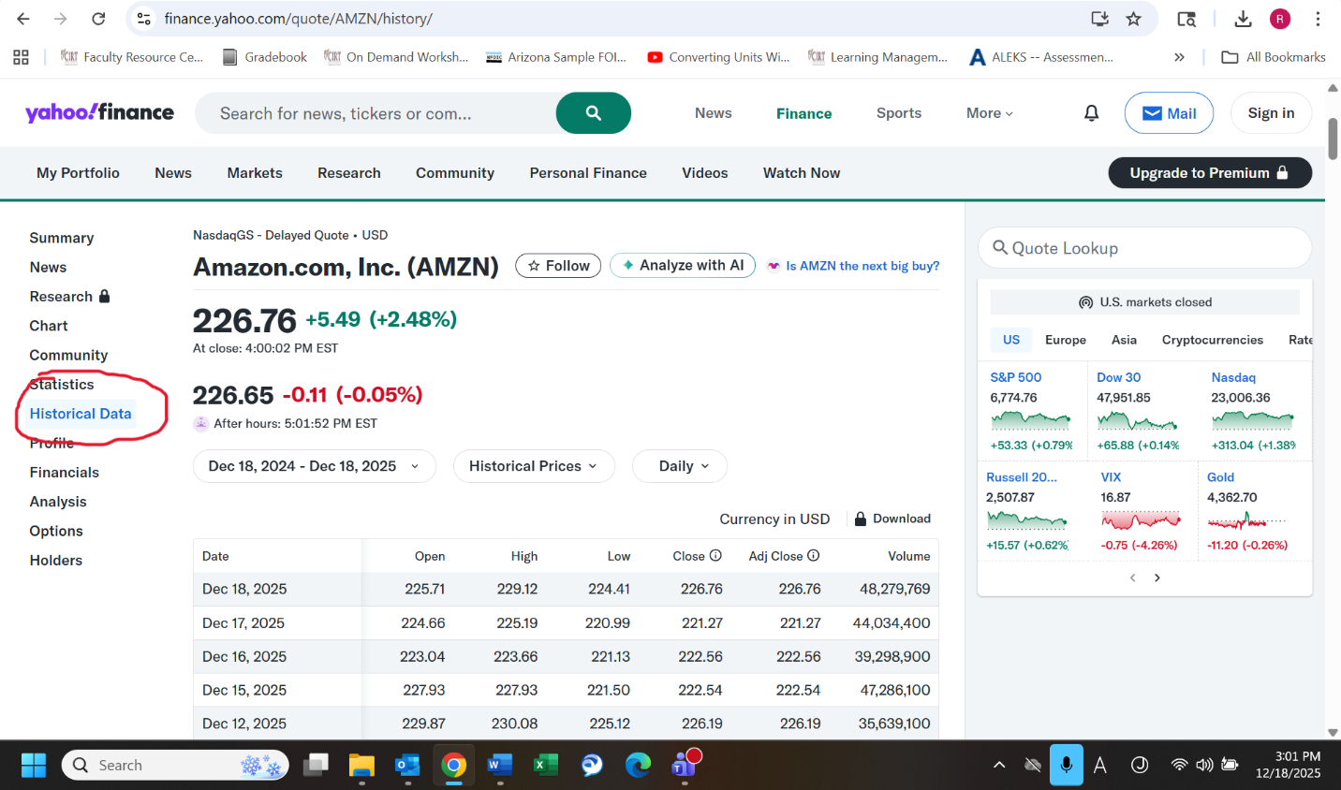

- Click inside the red circle to change the date range.

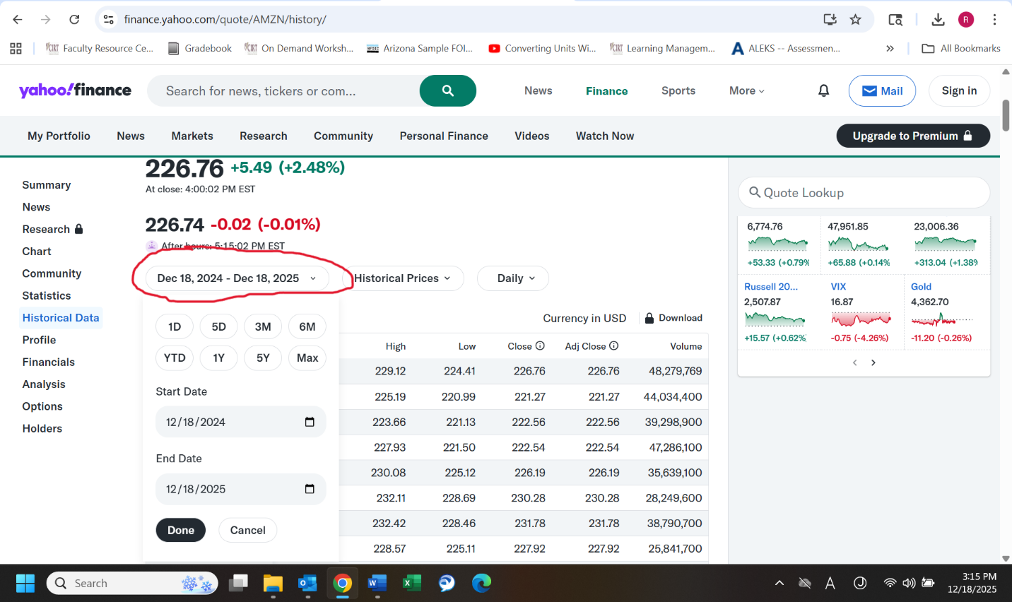

- Note that the initial investment is =number of shares * closing price per share + fee.

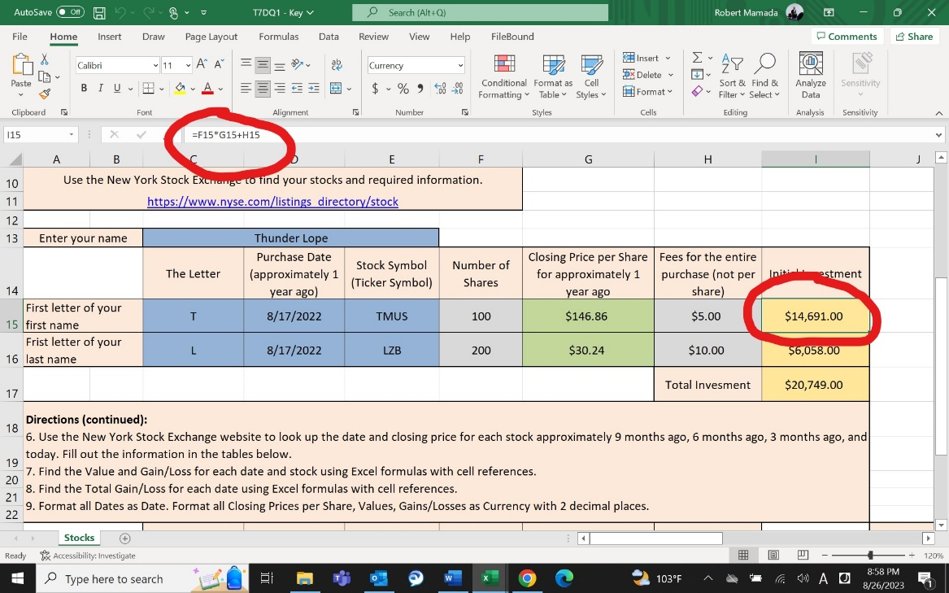

- The values in column G are =shares * closing price per share.

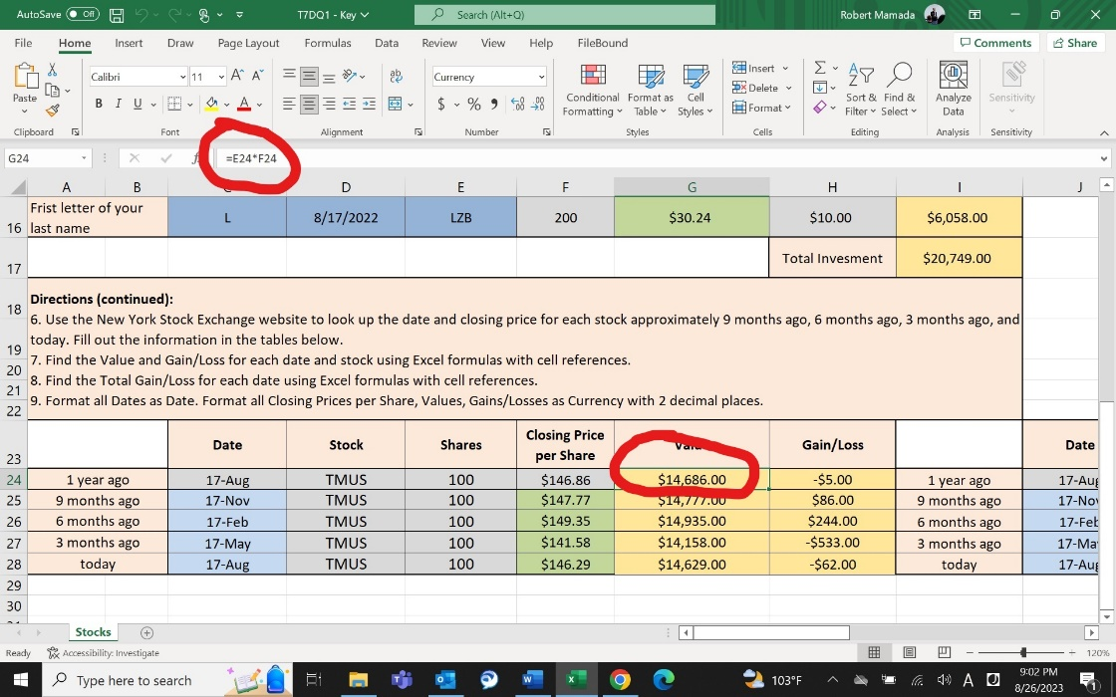

- The Gain/Loss is =value of that row – initial investment.

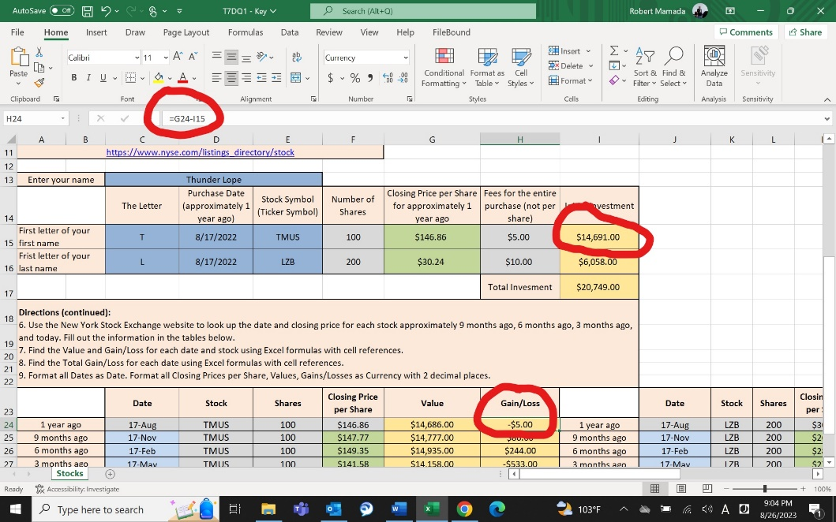

- The total gain/loss is =sum(gain/loss of first stock, gain/loss of second stock).

